**Multiple Choice Pre-Calculus Review**

**Non-Calculator Questions:**

Question 1:

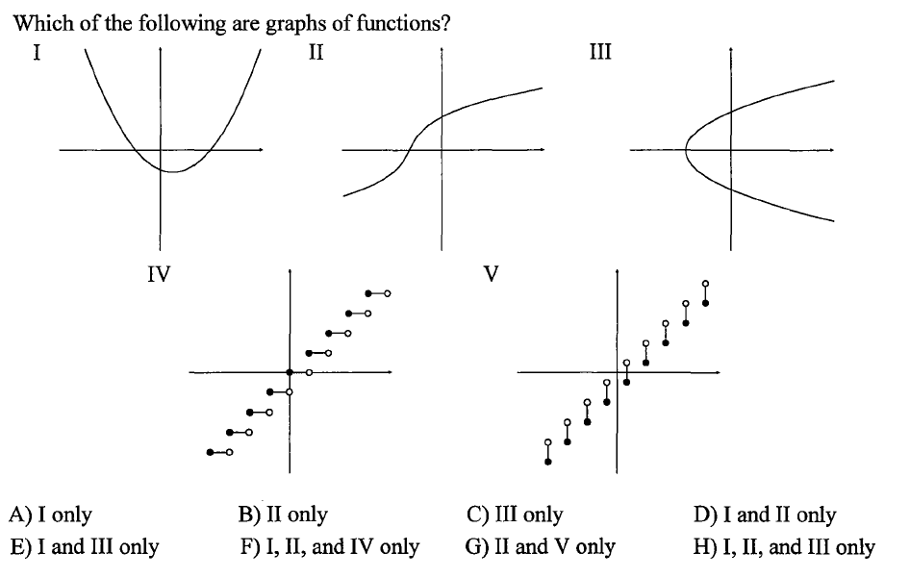

Question 2:

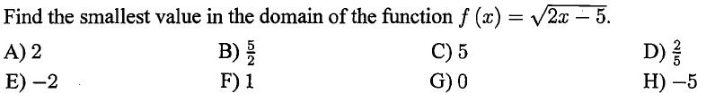

Question 3:

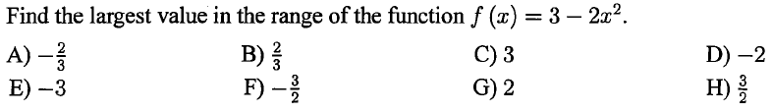

Question 4:

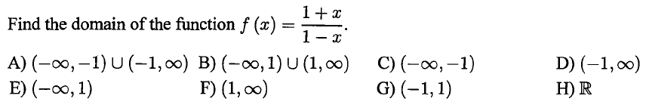

Question 5:

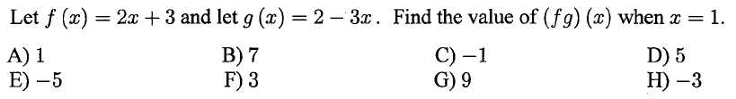

Question 6:

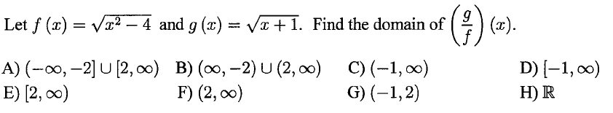

Question 7:

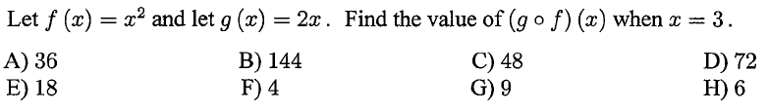

Question 8:

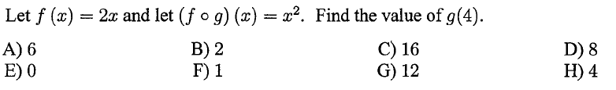

Question 9:

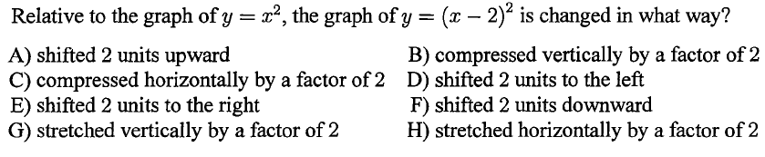

Question 10:

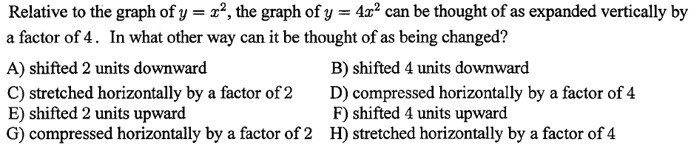

Question 11:

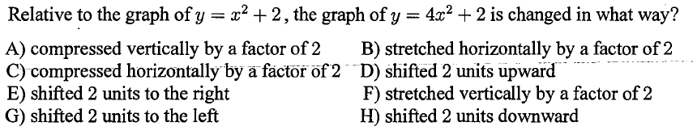

Question 12:

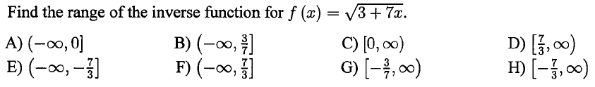

Question 13:

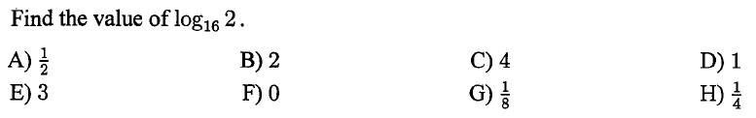

Question 14:

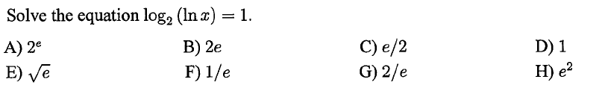

Question 15:

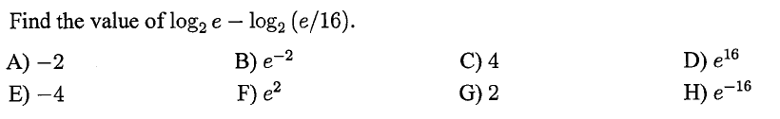

Question 16:

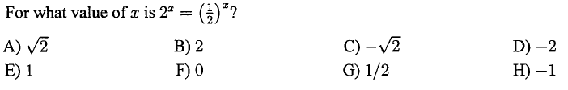

Question 17:

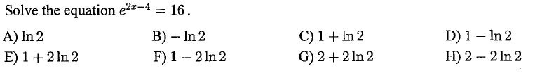

**Calculator Question:**

Question 18:

